FEN Chess Position Classification Using CNN

Snir Lugassy  206312506 | Gal Oshri  311363873 | Eilon Amram  205679780

Abstract

Forsyth-Edwards Notation (FEN) is a common notation for chess board state representation. In FEN each piece is represented using a unique letter, The white pieces are denoted using upper-case letters and the black pieces using lower-case letters.

We will train a Convolutional Neural Network to classify the unique state of a Chess board in FEN notation given images taken from online Chess website.

Architecture

We will consider 2 different approaches to build our network, the first approach is an “end-to-end” solution in which we will feed a picture of a board and output the predicted state of the board. The second is a “piece-by-piece” solution in which we train a CNN to classify a single square in the board (50×50 pixels) and apply it on each square to construct the predicted state of the board.

Both solutions will used Convolutional Neural Network with output layer size of 7 (corresponds to all possible pieces or an empty square). The “end-to-end” input dimension will be 400×400 while the “piece-by-piece” input dimension will be 50×50.

Chess Position Dataset

Our dataset consist of 100,000 images of chess boards taken from the online website “Chess.com”, with a size of 400×400 pixels. The boards has variety of colors, and the pieces has a variety of both shape and color.

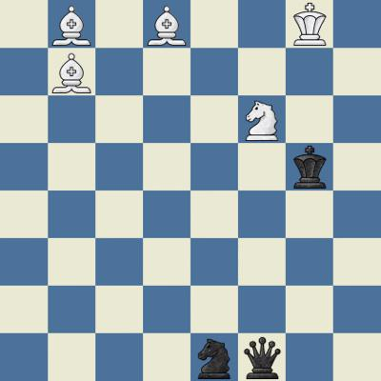Figure 1: Example board image

The state of each board in FEN is stored in the file name of the image file.

Forsyth-Edwards Notation Definition

The full FEN will describe many details about a certain game, we will consider only notation used to describe the piece placement in the board.

The piece placement is defined from the white player perspective, using 6 groups of characters separated by a delimiter. We will use ‘-’ as a delimiter (adopted from the dataset) although the original definition suggests the usage of ‘/’ as a delimiter.

Each group of characters corresponds to a row in the board from top to bottom, each character corresponds to a piece or space in the row from left to right according to the following dictionary:

“p” = Pawn
“n” = Knight
“b” = Bishop
“r” = Rook
“q” = Queen
“k” = King
1-8 = Number of empty squares

White pieces are represented using upper-case letters and the black pieces using lower-case letters.

The state of the board in Figure 1 using FEN is:

